### H_opengate_by_geist_logo_CMYK.jpgLINES.jpg

### Reclaim Wasted Cooling Capacity *Now Updated with* CFD Models to Support ASHRAE Case Study Data

### Peer reviewed case study data from ASHRAE *now updated* with CFD model analysis revealing more information and visual cues about best practice ceiling grate return and other passive cooling methods. Data validates that localized hot air leakage and recirculation is increasing server inlet temperatures and cool air bypass is lowering AHU/CRAC return temperatures. This paper also demonstrates how the Opengate EC system eliminates hot air recirculation and cold air bypass.

### EC9005A WHITE PAPER

Geist Global

Issued January 12, 2012

Abstract

Deployment of high density equipment into data center infrastructure is now a common occurrence, yet many data centers are not adequately equipped to handle the additional cooling requirements resulting from these deployments. This is resulting in undesirable conditions such as recirculation or mixing of hot and cool air, poorly controlled humidity and costly wasted cooling capacity. This paper will define; cooling over-supply, provide examples for quantifying cool air bypass and hot air recirculation, and assign principles to evaluate high-density rack performance and cooling efficiency benefits which are gained from Unity Cooling® - the raising of supply air temperature and supplying only the cooling required by the IT load.

Dynamics of Wasted Cooling Capacity

**Region in front of the IT rack**

IT equipment deployed into the data center environment will draw the volume of air it requires from the region in front of the rack. With higher density equipment now being deployed, the volume of air being pulled through the IT equipment rack is exceeding the volume of cool air being distributed at the face of the rack. As shown in *Figure 1*, this results in hot exhaust air recirculation to the equipment intakes.

**Figure 1:** With inadequate supply air volume at the face of the rack, today’s high density equipment is pulling in hot exhaust air.

**Floor tile gymnastics1**

****Achieving desired flow rates from floor tiles, or other types of cool air delivery methods, in front of every IT rack on the floor is complex and highly dynamic. According to Mitch Martin, Chief Engineer of Oracle’s Austin Data Center; “The excessive use of 56% open floor grates to achieve today’s higher required flow rates, greatly effects under floor pressure. Even with CFD (computational fluid dynamics) modeling, it is difficult to predict the effects on local floor pressures due to adding and moving floor grates.” *Figure 2* reveals the typical range of expected flow rates for two tile types. Variables effecting under floor pressure and the resulting tile flow rates are; size, aspect ratio and height of floor, positions and types of tiles, presence of floor leakage paths, size and orientation of CRAC/H (Computer Room Air Conditioner/Handler) units, under floor obstructions, CRAC/H maintenance and under floor work. Given the number of variables, it’s easy to understand why the desired flow rates are not being achieved at the face of the IT equipment rack. A visual representation of hot exhaust air recirculation over the top of the racks due to insufficient supply is shown in *Figure 3* **2***.*

**Figure 2:** Actual tile flow rates in a medium to large data center will vary significantly and on average be lower than expected due to many dynamic variables that are difficult to control.

**Cooling over provisioning approach**

A common approach to overcome cooling distribution problems at the face of the IT rack is to overprovision the volume of cooling and reduce the temperature of the cool air being supplied. This cool air is being delivered below the recommended ASHRAE low end limit to create the proper temperatures at the top of the IT equipment rack. Due to this unpredictable mixing of cooling overprovision with hot exhaust air from the IT equipment, a significant portion of cooling that is generated is never utilized, but rather is short cycling back to the cooling units.

**1** ASHRAE Innovations in Data Center Airflow Management Seminar, Germagian, Winter Conference, January 2009

**2** ASHRAE Journal Article, Designing Better Data Centers, December 2007

**Figure 3:** CFD model providing visual representation of hot air recirculation to the face of the IT equipment rack due to cool air supply instability.

**Revised ASHRAE Standards for Mission Critical IT Equipment**3

To provide greater operational flexibility, with emphasis on reduced energy consumption, Technical Committee (TC) 9.9 in coordination with equipment manufacturers has revised the recommended environmental specifications.

**2008 Revised Equipment Environment Specifications:**

|  |  |
| --- | --- |
| Low End Temperature: 18°C (64.4 °F) | Low End Moisture: 5.5°C DP (41.9 °F) |
| High End Temperature: 27°C (80.6 °F) | High End Moisture: 60% RH & 15°C DP (59°F DP) |

*As stated by ASHRAE, the low end temperature limit should not be interpreted as a recommendation to reduce operating temperatures as this will increase hours of chiller operation and increase energy use.*

A cooling distribution strategy which allows supply air temperatures to approach the ASHRAE high end limit will improve CRAC/H capacity, chiller plant efficiency and maximizes the hours of economizer operation.

### Hot Air Leakage and Cool Air Bypass

Hot air leakage from the IT rack to the intake of the IT equipment and excess cool air bypass in the data center will limit your ability to increase rack density, raise supply air temperature, control the environment and improve cooling efficiency. The separation of cool supply and hot exhaust air is one step toward a cooling distribution strategy for high-density computing. Methods that provide physical separation such as; rack heat containment, hot aisle containment and cold aisle containment are being deployed, however without proper management, leakage and bypass is still an issue. Examples of cool air bypass and hot air leakage associated with rack heat containment are depicted in the two figures below.4 *Figure 4* illustrates the percentage of cool air bypass for a constant hot exhaust volume flow and a particular IT equipment load. It is clear that a lower IT equipment load for the same hot exhaust flow will create greater cool air bypass percentages. *Figure 5* demonstrates hot air leakage out of the IT rack caused by high pressure in the lower and middle regions inside the rack. Not shown are the other predictable leakage areas such as; around side panels, door frames and server mounting rails. Hot air leakage will elevate IT intake air temperatures. Rack pressure in passive rack heat containment is highly dependent on IT equipment airflow volume and rack air leakage passages. A tightly sealed rack having fewer air leakage pathways will create greater rack pressure for the same flow rate. Hot and cold aisle containment exhibits similar leakage and bypass characteristics based on aisle air leakage passages and airflow volume mismatch to and from the contained aisle.

**Figure 4:** Active rack fan releasing 1640 CFM to ceiling plenum for 1400 CFM load represents 240 CFM (17%) cool air bypass.

**Figure 5:** Passive rack releasing 1040 CFM to ceiling plenum for 1400 CFM load represents 360 CFM (26%) hot air leakage.

**3** 2008 ASHRAE Environmental Guidelines for Datacom Equipment -Expanding the Recommended Environmental Envelope

**4** ASHRAE High Density Data Center Best Practices and Case Studies book, November 2007

**Hot air leakage and cool air bypass when using a ceiling plenum return**

A ceiling plenum provides viable physical separation of cool supply air from hot return air. Using return grates in the ceiling for the hot air to penetrate will compromise the physical separation and allow hot air leakage in the center of the room furthest from the CRAC/H returns and cool air bypass in the regions closer to the CRAC/H returns. Relying on negative pressure in the ceiling plenum to pull air through a ceiling grate or rack heat containment exhaust duct is highly dependent on; room size, ceiling plenum size, size and distance between CRAC/H returns and rack exhaust air flow rates.

In ceiling regions closest to the CRAC/H return slight negative pressures can develop, helping to remove some rack pressure created by the IT fans in the rack; however, pressure in the middle and bottom of the rack is likely to remain positive and thus create additional work for the IT equipment fans and additional hot air leakage paths.

Hot air leakage can be exacerbated in racks that are farthest away from the CRAC/H returns. In these regions, slight positive pressures can develop in the ceiling plenum due to multiple racks’ exhaust flows and low return flows generated by the CRAC/H units. With a fan assisted rack exhaust duct, moving the same or more flow than the IT equipment in the rack, a positive ceiling pressure will have no measurable effect on rack hot air leakage and will provide a good rack plenum environment for IT equipment fans to do their job.

**Leakage and bypass in a mixed system**

The CFD model of *Figure 6* represents a mixed system with 70% of the IT racks having managed rack heat containment and the remainder of the IT racks with only return grates in the ceiling over the hot exhaust areas. This mixed system of rack heat containment and ceiling return grates demonstrates a stable IT environment when supplying 20% more cooling than is required by the IT equipment. As can be seen in *Figure 6*, the predictable bypass passages for the majority of the additional 20% cool air being supplied are the ceiling return grates. Also visible in *Figure 6* is the lower return temperature to the CRAC/H units closest to the ceiling grates due to the cool air bypass. A managed cooling distribution solution should aim to eliminate leakage and bypass while providing tools to report the actual cooling being demanded by the IT equipment. Further, dynamic controls to maintain a 1:1 cooling supply to IT demand relationship should be considered in the overall solution to maximize cooling efficiency.

**Figure 6:** A mixed system of managed rack heat containment and ceiling return grates demonstrates necessary cooling over-supply due to cool air bypass through ceiling return grates.

Updated Analysis: **CFD Modeling Project Compares *Ceiling Grate Return* to *Opengate EC* for a Single Suite within the Larger Facility**

**Computational Fluid Dynamics Modeling Parameters**

* Compare two models; 1) Ceiling grate return and 2) Opengate Containment Cooling in one of the four suites
* All models have the same raised floor, room envelope and ceiling plenum vertical height.
* Perimeter AC units will be run at 88% of total airflow and temperature delivery constant.
* Perforated floor tiles in cold aisles and ceiling grates in hot aisles
* Each individual suite total IT load will be evenly distributed across the number of racks in that suite.

**Data Center Shell**

* Facility of 5,429 sq.-ft.
* Overall Height 149in.
* 18in. Raised Floor
* 29in. Dropped Ceiling

**Data Center Loading and Cooling**

* 620 kW of IT Load
* PDU dissipation set to 3% of IT power output
* UPS heat dissipation set to 22 kW each
* 26 Ton Perimeter Cooling units (qty. 11) set to 88% of full capacity airflow (7,920 CFM) each
* Cooling unit returns are ducted to the ceiling plenum
* Supply air temperature fixed at 58F and supply air volume for each 26T CRAC at 7,920 CFM.
* 120 CFM per kW (industry accepted average) will be used to determine IT air volume flow rates.
* Server load evenly distributed within rack from 1U to 38U
* Typical rack gaps and leakage modeled
* Racks have solid back doors and cabinets without EC20 units have sides opened to the adjacent EC20 cabinets

3D Model of Suite Being Evaluated Within Larger Facility

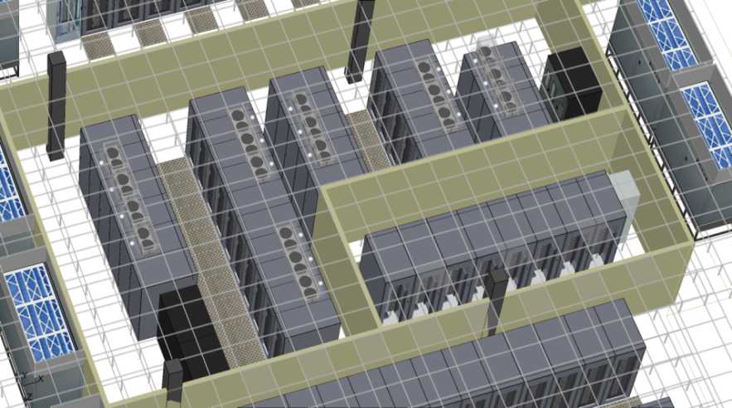

Rack Power Load Distribution for Suite

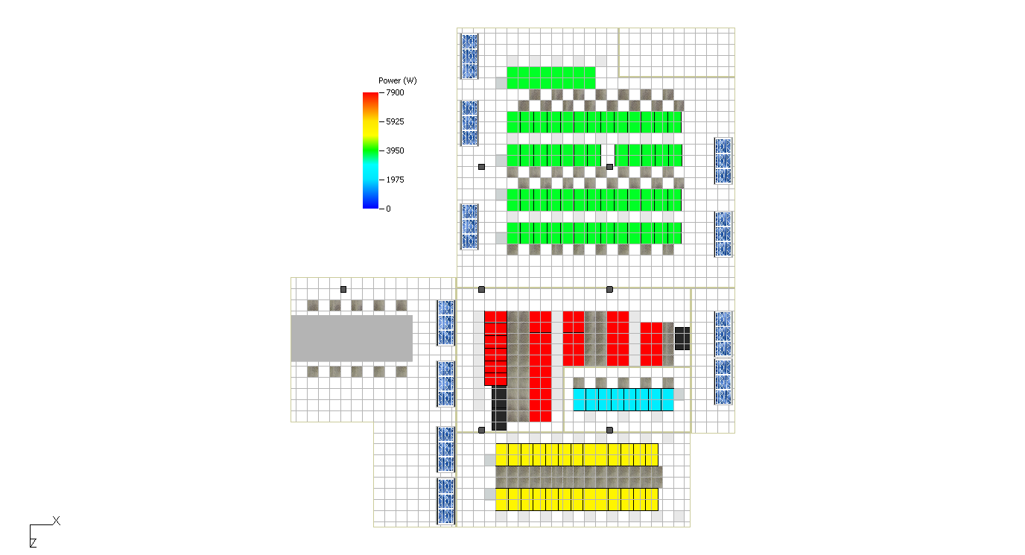



Cooling Unit and Rack Load

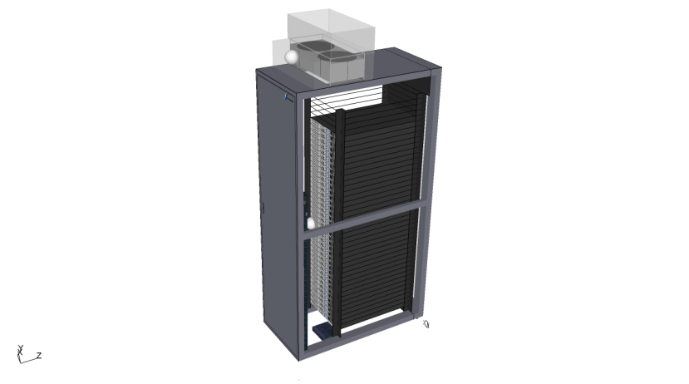

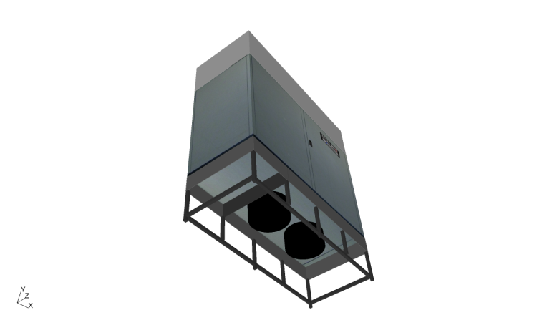

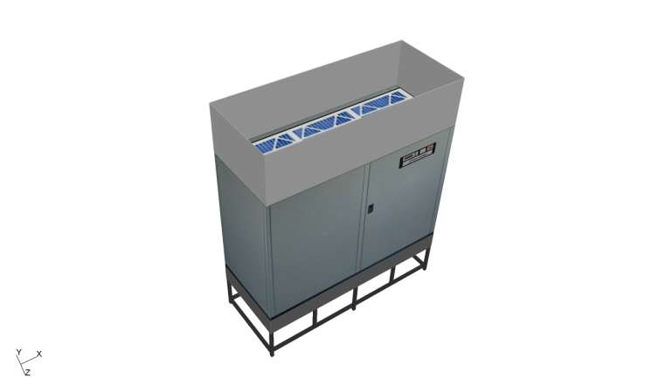

26 Ton Cooling Unit with Return Duct Extension and Sub-floor Plug Fans

Opengate EC Supporting Rack Load

**CFD Plots Comparing Ceiling Grate to Opengate EC at 20U and 30U Rack Positions**

`

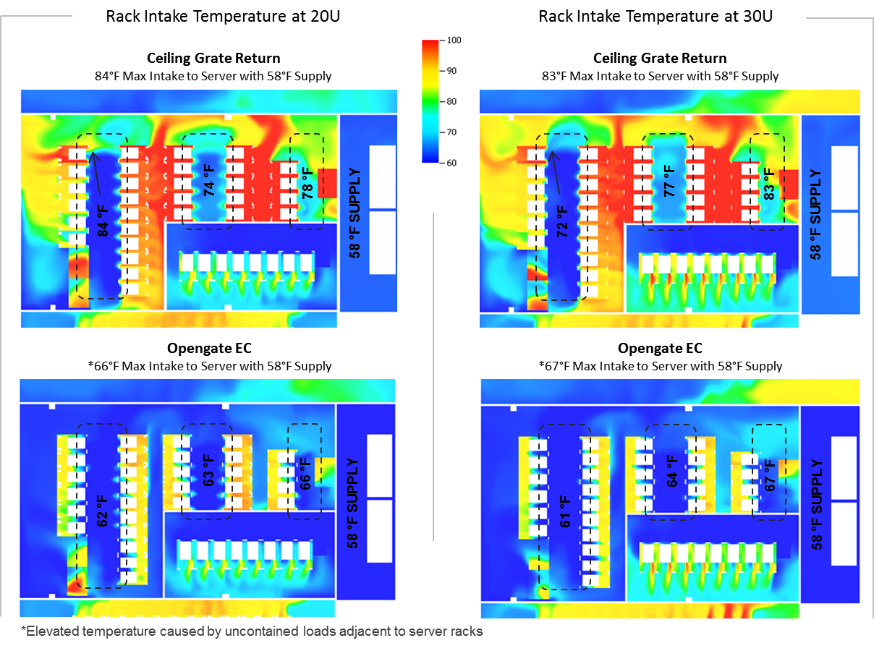

**CFD Modeling Conclusions: Ceiling Grate versus Opengate EC**

* CFD modeling data correlates with empirical data and proves to be a good tool to compare between the two designs.
* Ceiling grate return does not address cool air bypass. Cool air is returned to the cooling units unused and when more cool air is generated to compensate, cool air bypass increases further.
* Opengate EC20 in suite eliminates cool air bypass, leaving more cooling for the IT load in the other suites.
* To take advantage of the cooling waste reduction in suite, supply volume can be reduced from the AC units and by eliminating some floor tiles. This will result in more air for other suites in the facility.
* At full data center loading and with Opengate EC in suite, no hot spots and better stability of rack intake temperatures was achieved.
* When Opengate is deployed in remaining suites supply air temperature can be raised from 58 to 68 Degrees Fahrenheit allowing maximum hours of free cooling.

**Updated Analysis:** CFD Modeling Compares *Passive Rack Chimney* (Metal Extension Duct at Top of Rack) to *Opengate EC*

**Rack-Based Heat Containment**

With rack-based heat containment the flow rate exhausting out the rack top chimney must closely match the server flow rates to prevent localized hot air leakage and cool air bypass. The following diagram comparing flow rate matching for Helper Fan and Passive is courtesy of ASHRAE from the Case Study Book on High Density Data Center Best Practices. Also included for comparison is the Opengate EC with Server exhaust airflow matching.

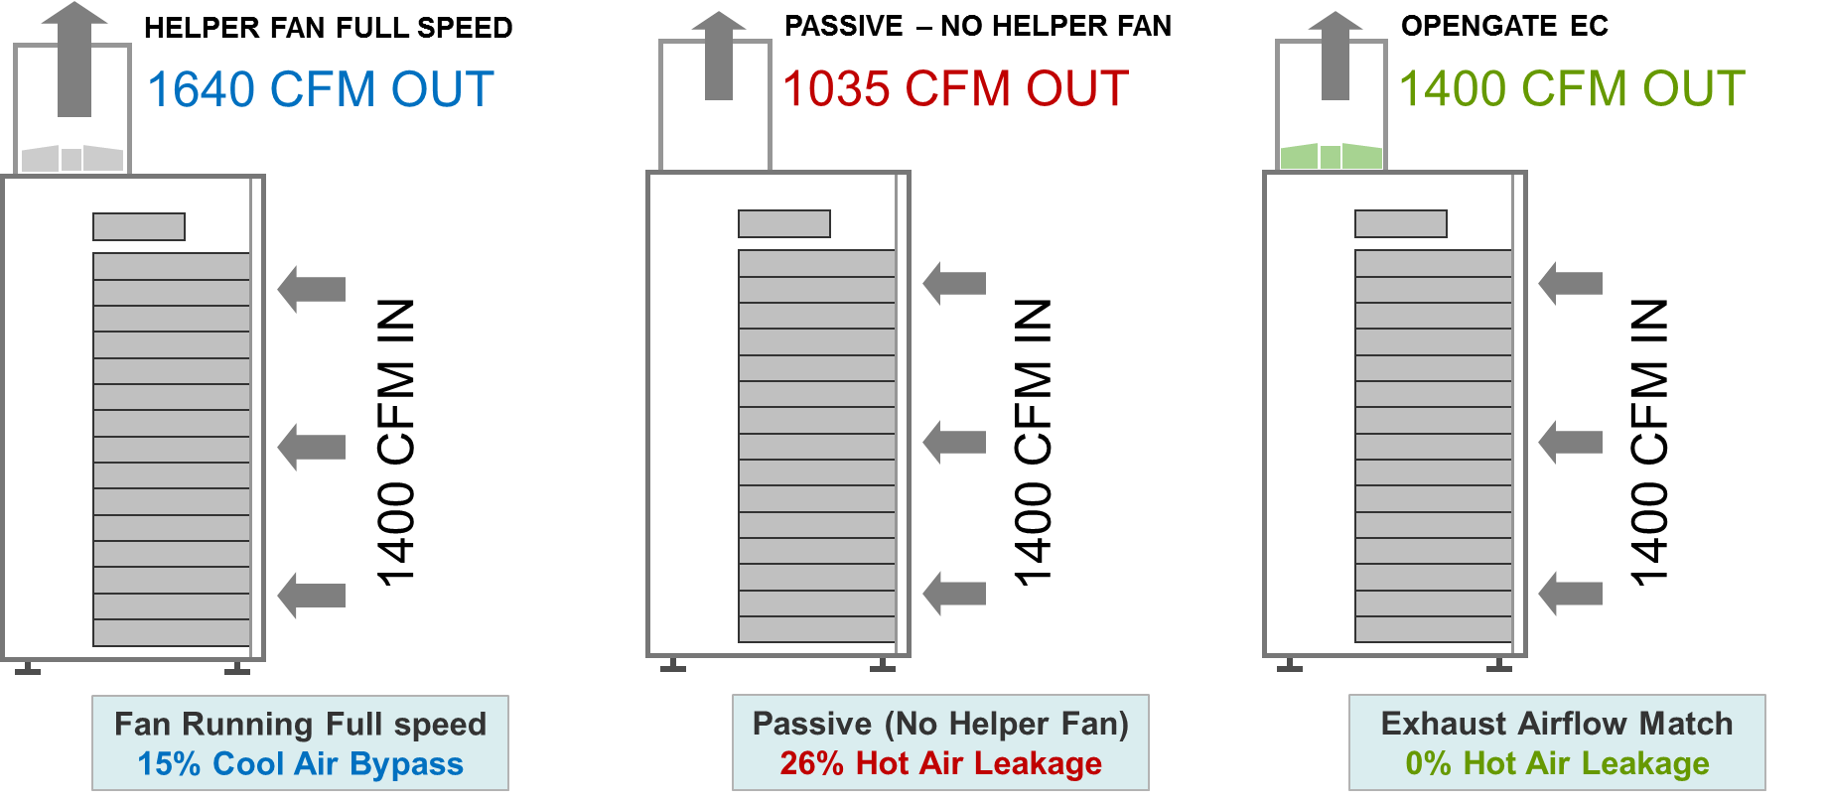

**ASHRAE CFD Study: Standard Racks with Perforated Front and Rear Doors – Where are the localized hot air Leaks?**

Rack loads of 5, 10, 15 and 20 kW showing hot air leakage at rack front rails and rack front bottom. 20% of hot air leakage for 5 kW rack load and a big jump to 37% hot air leakage for a 10 kW rack load. Rack construction and daily maintenance on the IT floor creates many paths for heat to recirculate back to the IT equipment intakes: Around servers, between servers, through idle servers and through gaps in metal racks. The following diagrams are courtesy of ASHRAE Journal Article; Rack Enclosures, A Crucial Link in Airflow Management in Data Centers. Kishor Khankari, Ph.D., Member ASHRAE.

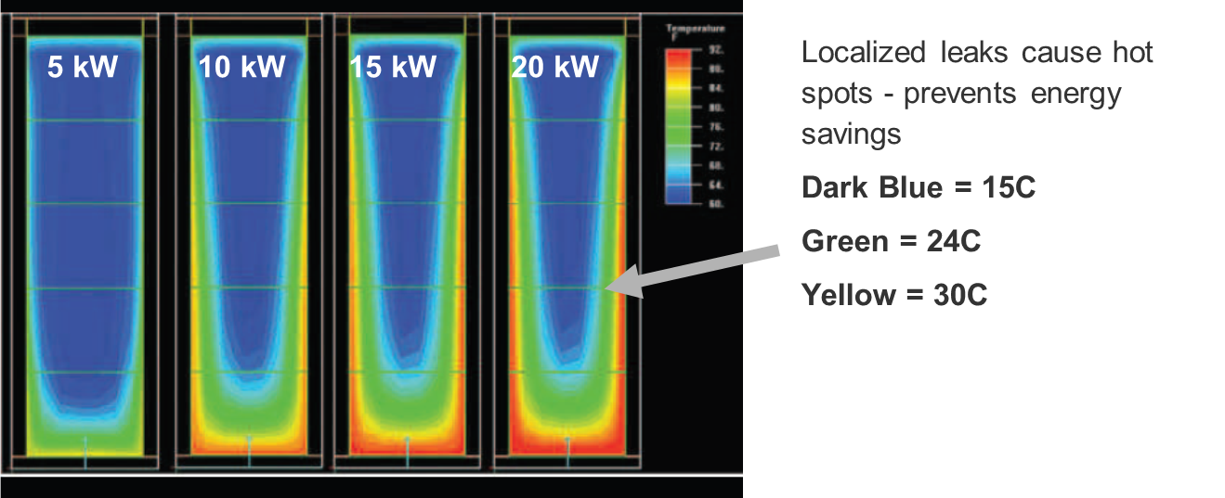

**ASHRAE CFD Study: Attempts to Seal the Server Rack to Prevent Localized Hot Air Leakage is Driving Rack Pressure Higher**

Server manufacturers will not warranty servers placed in operating environments they have not been designed for. High positive pressure in the area behind the server exhaust is causing restricted flow through servers and/or increased server fan speed to compensate. The following diagram, also courtesy of ASHRAE, shows rack pressure increase with leakage paths blocked for the four different rack loads. These pressures are for racks with perforated front and rear doors. Racks with passive chimneys having solid rear doors and no helper fan would have even greater pressure behind the server.



**CFD Model Demonstrates Localized Hot Air Leakage.**

With pressure in rack created by server exhaust and the typical restricted flow from a 2 FT x 2 FT passive chimney; server intake temperatures are 10 to 16°F greater than the data center supply air temperature.

**Server Inlet Temperature Distribution**

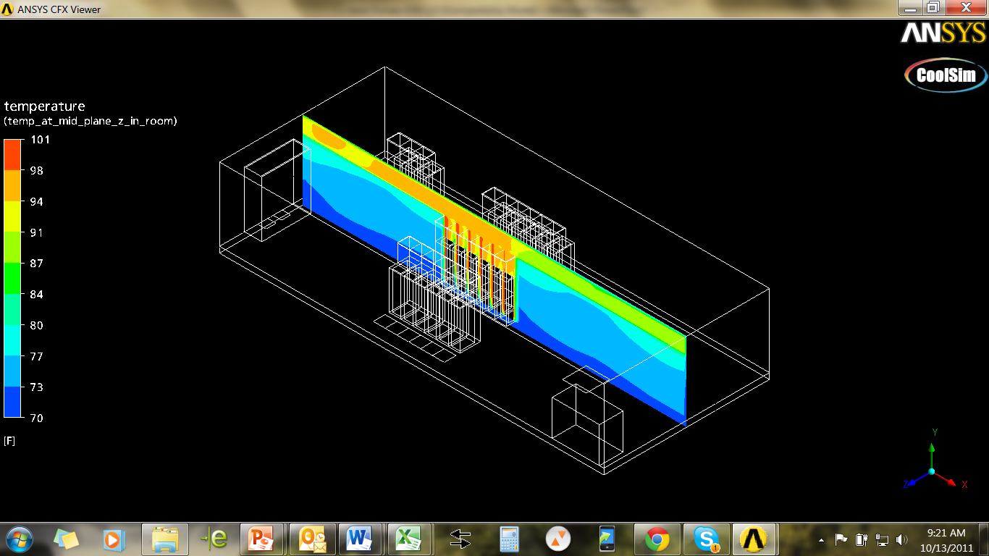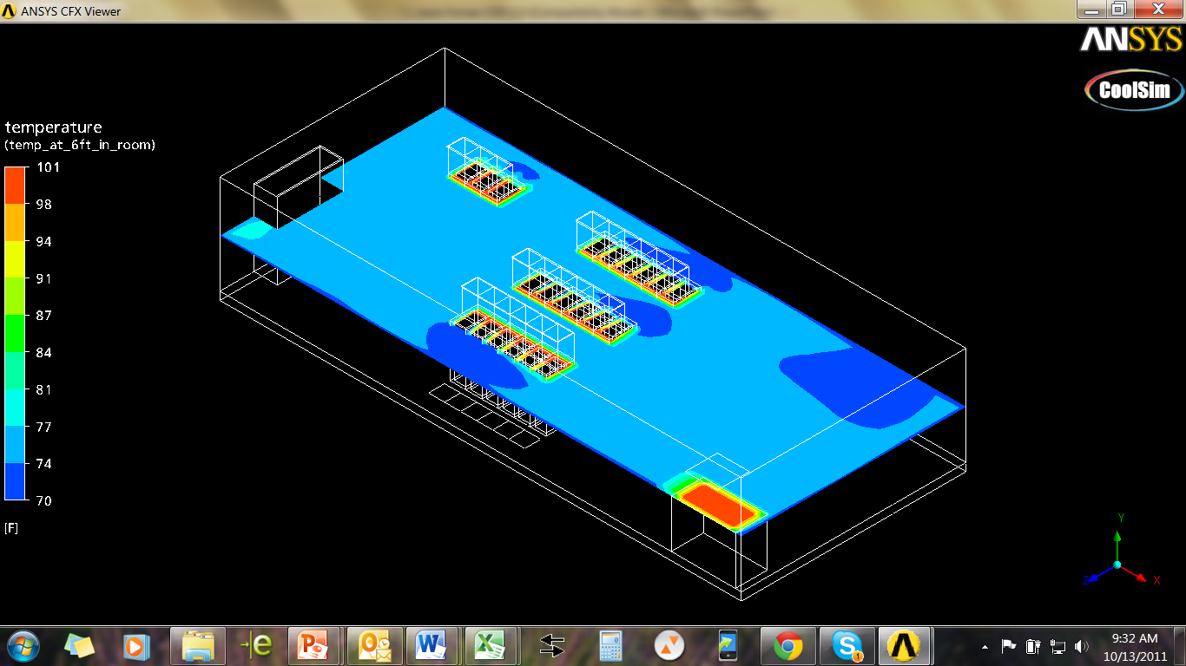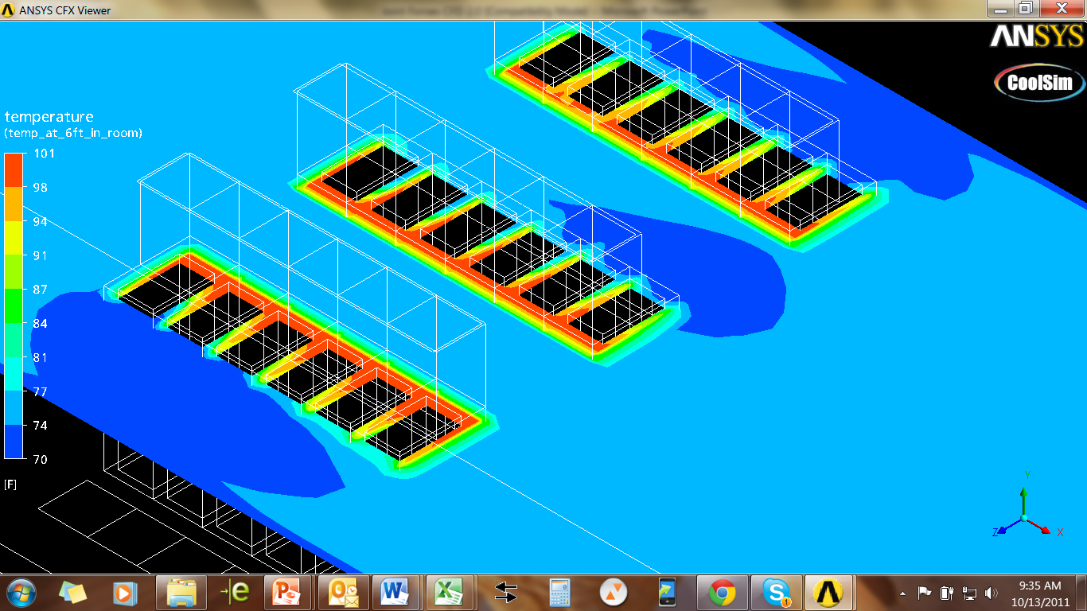

86F Inlet Temp

70F Supply Air Temp

Localized leakage of hot server air requires cooling to the worst hot spot in the data center, hampering plans to save energy on cooling. These localized hot spots also prevent additional server deployment. Based on this model, the supply temperature would need to be reduced and additional cool air volume would need to be increased.

**Ceiling Plenum Pressure Plot**

With 12% oversupply, the ceiling pressure above the racks is slightly negative. Larger amounts of oversupply would be needed to create a greater negative pressure in the ceiling. This ceiling pressure is considerably lower pressure than the area behind the servers. Based on this, the pressure behind the servers and the resulting hot air leakage will remain. Servers in passive chimney racks will be working harder due to high rack pressures.

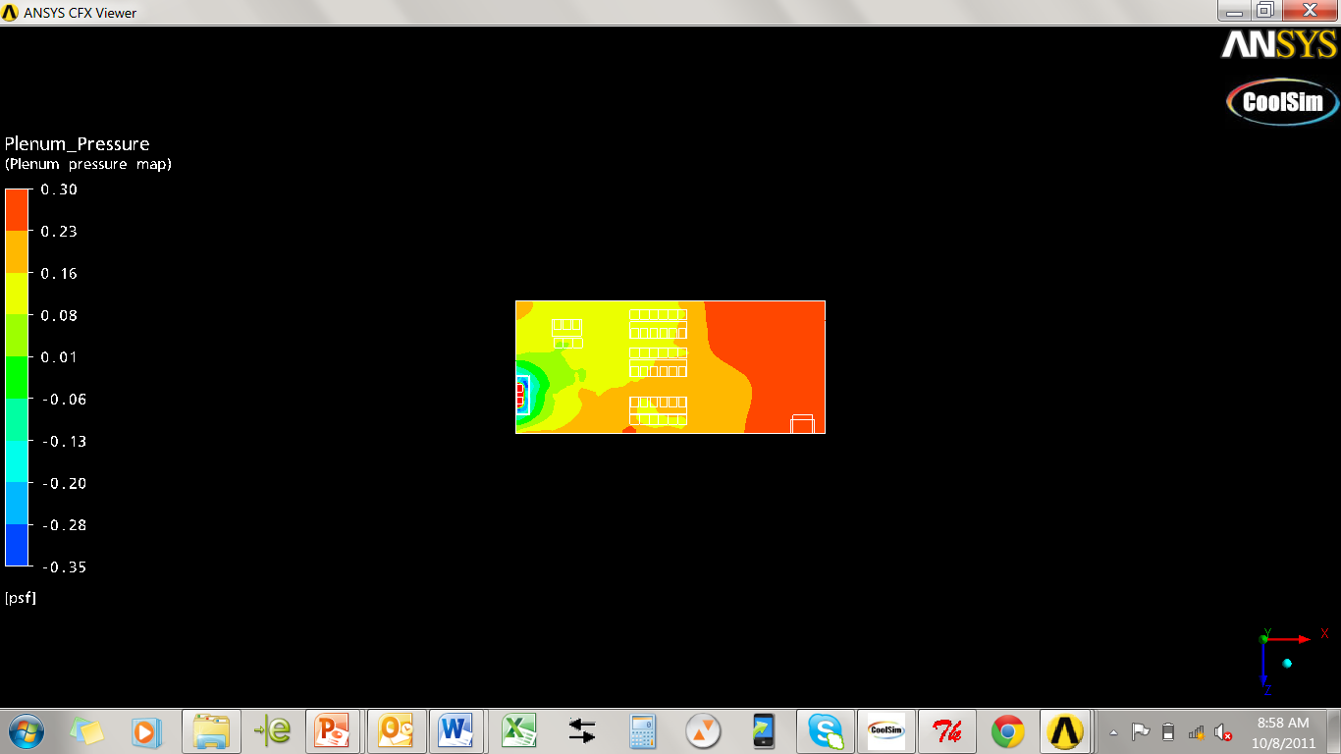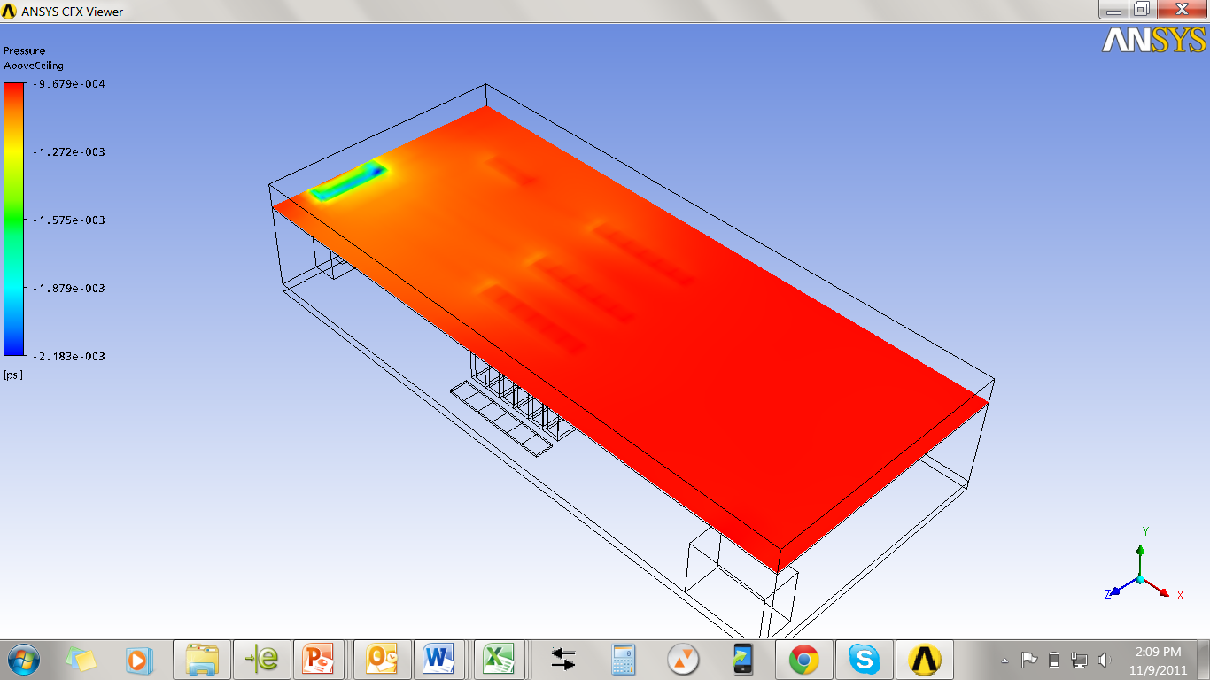

**- 0.0009**

**- 0.0013**

**- 0.0016**

**- 0.0019**

**- 0.0022**

Actual ceiling pressure would be lower due to leakage in the typical ceiling plenum construction that is not modeled in CFD. Ceiling pressure distribution variation in this model highlights the requirement for active rack heat containment.

**Updated Material:** Department of Energy DCEP Training Slide

**Containment Cooling Should Aim to Contain 100% of the Server Hot Air and Prevent Cool Air Bypass**

The following provided by Geist Global represents 100% heat containment at the source (server) with room temperature essentially the same as the supply air temperature. With this method, the option to supply cooling dynamically to match the IT load changes is possible since no hot air is recirculating. Air delivery options such as; vertical overhead supply, through wall or upflow perimeter units are possible for raised floor or slab floor.

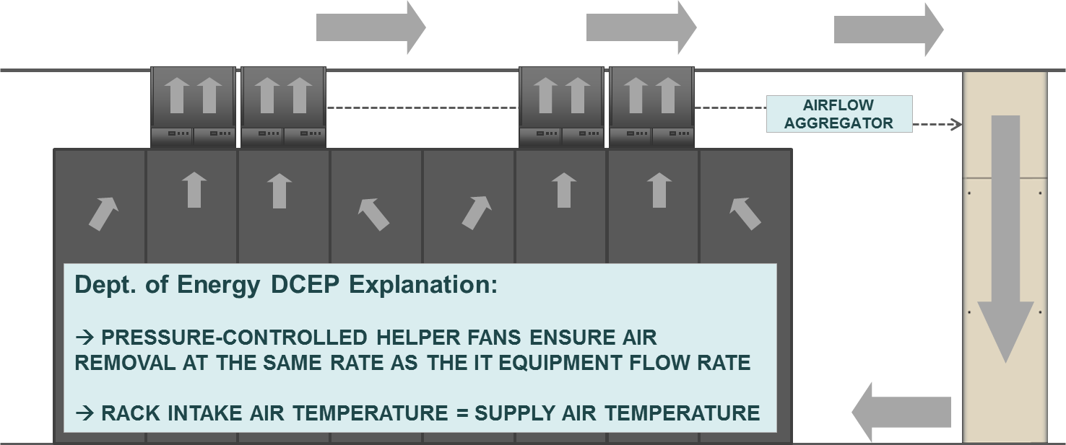

### Stranded Cooling Capacity Efficiency Consideration

**CRAC/H fan and server fan performance efficiency consideration**5

Data center wide fan power efficiency must be evaluated when choosing a cooling strategy. It is important to note that fan power and airflow do not have a linear relationship. The cubic fan power law has a significant effect on fan power consumption. For example; with a fan delivering 50% of the rated airflow capacity, the power consumption of the fan is slightly more than 10% of its full rated power. Speed controlled CRAC/H fans to eliminate overprovision has a greater effect on energy efficiency improvements than just turning off over provisioned CRAC/H units. Server fans consuming less air, resulting in higher exhaust temperatures for the same intake air temperature, will provide efficiency gains that cascade across the entire power and cooling infrastructure. A cooling strategy allowing deployment of high delta-T servers is critical.

**Lost opportunity cost – unrealized capacity**

Reclaiming stranded cooling will have a significant effect on maximizing the life of existing data centers. When over-supplying cooling, the impact to business is a realized load that is significantly less than the design load. Excess airflow, low CRAC/H capacity due to low supply/return temperatures, and low chiller plant efficiency and hours of economizer operation all contribute to unrealized capacity. As illustrated in *Figure 7,* the inefficiency of cooling over-supply could mean as much as 1.2 megawatts of stranded or lost capacity for a 2 megawatt design. As illustrated in *Figure 8*, a 2 megawatt design partially loaded to 1 megawatt would waste 30% of the CRAC/H fan power with 50% cooling over-supply.

## 5 Oracle Heat Containment Presentation at PIAC Conference, Data Center Conservation Workshop, IBM, August 2007

At 50% cooling over-supply for a 2 megawatt design load, the green curve in *Figure 8* illustrates that only 1.3 megawatts of data center capacity is realized at full CRAC fan power. With CRAC fans controlled to 40% of full rated power, the realized capacity is 1 megawatt. Alternatively, if we eliminate cooling over-supply as illustrated by the dark blue curve of *Figure 8*, CRAC fans would only need to run at 12% of their full rated power to realize 1 megawatt of data center load. Using this example, cooling fans consuming 20 kW to properly provision the 1 megawatt part load, would consume 68 kW in the 50% over-supplied data center and consume 160 kW in the 100% over-supplied data center.

**Figure 7:** Impact of data center design load and over-supply percent on realized data center capacity

Additional lost opportunity cost factors to consider in such an analysis would include: the ability to maximize rack and row density to gain maximum use of existing real estate, continued use of cost effective and large air handlers or perimeter cooling, reduced installation and service costs, reduced user interaction with floor tile gymnastics and greater availability - achievable with a data center free of hot air recirculation.

**Figure 8:** Impact of over-supply percent and partial data center loading on percent of maximum fan power for CRAC/H having adjustable flow rates

### CRAC/H and chiller efficiency considerations6

A CRAC/H unit deployed in a system allowing a higher supply and return temperature will operate at greater efficiency. *Table 1* data supplied by a CRAC/H manufacturer demonstrates this cooling capacity increase. Referring to *Table 1*, the top line is fairly close to a conventionally cooled data center with return temperature controls. With supply air conditions well outside of the ASHRAE Class 1 standard, the sensible cooling of 107 kW is quite a bit lower than the total cooling of 128 kW. The CRAC is also capable of increased capacity as the return air temp is elevated. With the return dry bulb air at 100 ºF, the CRAC capacity almost doubles.

**Table 1:** 45 ºF entering chilled water temperature with controlvalve full open

|  |  |  |  |  |  |  |
| --- | --- | --- | --- | --- | --- | --- |
| **Return Dry Bulb (ºF)** | **% Rh** | **Leaving Fluid Temp (ºF)** | **Total Cooling (kW)** | **Sensible Cooling (kW)** | **Sensible Ratio (SHR)** | **Supply Dry Bulb (ºF)** |
| 72 | 50.0 | 58.5 | 128 | 107 | 83% | 51.1 |
| 80 | 38.3 | 62.0 | 164 | 144 | 88% | 51.4 |
| 90 | 27.8 | 66.5 | 210 | 188 | 90% | 52.1 |
| 100 | 20.4 | 71.0 | 255 | 228 | 89% | 53.2 |

## 6 Oracle Heat Containment Presentation, PIAC Conference, Data Center Conservation Workshop, IBM, August 2007

*Table 2* data demonstrates maintaining a 68 ºF supply dry bulb to increase total cooling and improve the sensible heat ratio (SHR) to allow even greater sensible cooling. Data indicates that the CRAC requires a lower cooling water flow rate and this performance indicates it might be most efficient to dial back some cooling capacity and let the chillers run at their most efficient operating parameters. Greater temperature differential from chilled water and return air improves coil performance.

**Table 2:** 45 ºF entering chilled water temperature with controlvalve throttled

|  |  |  |  |  |  |  |
| --- | --- | --- | --- | --- | --- | --- |
| **Return Dry Bulb (ºF)** | **% Rh** | **Leaving Water (ºF)** | **Total Cooling (kW)** | **Sensible Cooling (kW)** | **Sensible Ratio (SHR)** | **Supply Dry Bulb (ºF)** |
| 80 | 38.3 | 76.0 | 204 | 192 | 94% | 68.2 |
| 90 | 27.8 | 85.2 | 371 | 355 | 96% | 68.3 |
| 100 | 20.4 | 93.1 | 545 | 516 | 95% | 68.1 |

Manufacturer’s data demonstrate that chillers run more efficiently and give additional capacity if the chilled water temperature is raised. By raising the entering chilled water temperature from 45 to 50 ºF a R134-A high-pressure chiller realizes a 9% capacity increase and a 6% energy savings and a R123 low pressure VFD chiller realizes a 17% capacity increase and a 12% energy savings. Increasing chilled water temperature will also provide increased hours for available water-side economizer operation, to the point where it becomes economically feasible even in warmer climates. Raising the supply air temperature to 70 ºF would require approximately 55 ºF chiller condenser water. In comparison, a 59 ºF supply air temperature would require approximately a 45 ºF condenser water temperature. With a 5 ºF approach temperature, water-side economizers could be utilized at outdoor air temperatures up to 50 ºF for a 70 ºF supply versus outdoor air temperatures up to 40 ºF if supply air is left at 59 ºF.

**Conclusions**

Reclaiming wasted cooling capacity which results from hot air leakage and cool air bypass is possible with an intelligently managed cooling distribution system. Physical barriers to separate cool supply from hot return air without proper management techniques is likely to create issues for IT equipment operation, allow too much leakage or bypass air from racks or contained aisles and hamper environment stability and energy saving efforts. Real-time reporting of actual rack airflow consumption supports the elimination of cooling over-supply when the rack airflow consumption data stream is aggregated across the entire data center and used to automatically or manually turn CRAC/H units on or off, or is utilized as input to control CRAC or air handler fans. The ability to more closely match the cooling supply volume to the IT consumption provides one of the greatest cooling efficiency improvements available; however free water side economizer cooling offers additional benefits even in warmer climates. When a managed cooling distribution strategy is utilized, the greatest savings is likely to come from your ability to maximize data center real estate and other resources by maximizing rack and floor density while using existing or familiar cooling systems, such as perimeter cooling or air handlers. This is particularly useful for maximizing energy efficiency as the data center floor is only partly loaded; the greater savings is recouped earlier in the life of the data center. Finally, an intelligently managed system, by definition, can provide real-time reporting, alarm notification, capacity assessment and planning for the data center operator and individual customers in a colocation environment.

About the Author: Mark Germagian oversees Geist’s new product development with the responsibility to lead the firm into new technology areas relating to effective and efficient data center operation.  Prior to Geist, Mark evolved intelligent containment technology and started Opengate Data Systems where he directed technology development, producing innovative power and cooling products for telecom and information technology environments. Mark is a contributing author for ASHRAE TC9.9 datacom series publications and holds multiple U.S. and international patents for power and cooling systems.

Geist

Geist designs and manufactures industry leading technology and software for powering, cooling and managing critical data center infrastructure. We produce affordable, quality products while providing our clients with superior service. Whether it’s enhancing customer care services or implementing new technologies, Geist promotes innovation, quality, and satisfaction in all aspects of business. [www.geistglobal.com](http://www.geistglobal.com)